Printable Blackboard Assignment Instructions

How do I add an assignment?

- Enter a folder in your Course Content where you want the assignment.
- Make sure the Edit Mode button is ON.
- Click Assessments and select "Assignment".
- Complete the Assignment Information, Assignment Files, Due Dates, Grading and Availability information.
- NOTE: Even if you assign zero points for an assignment (making it Extra Credit), it will still create a column in the Grade Center.
- Click Submit.

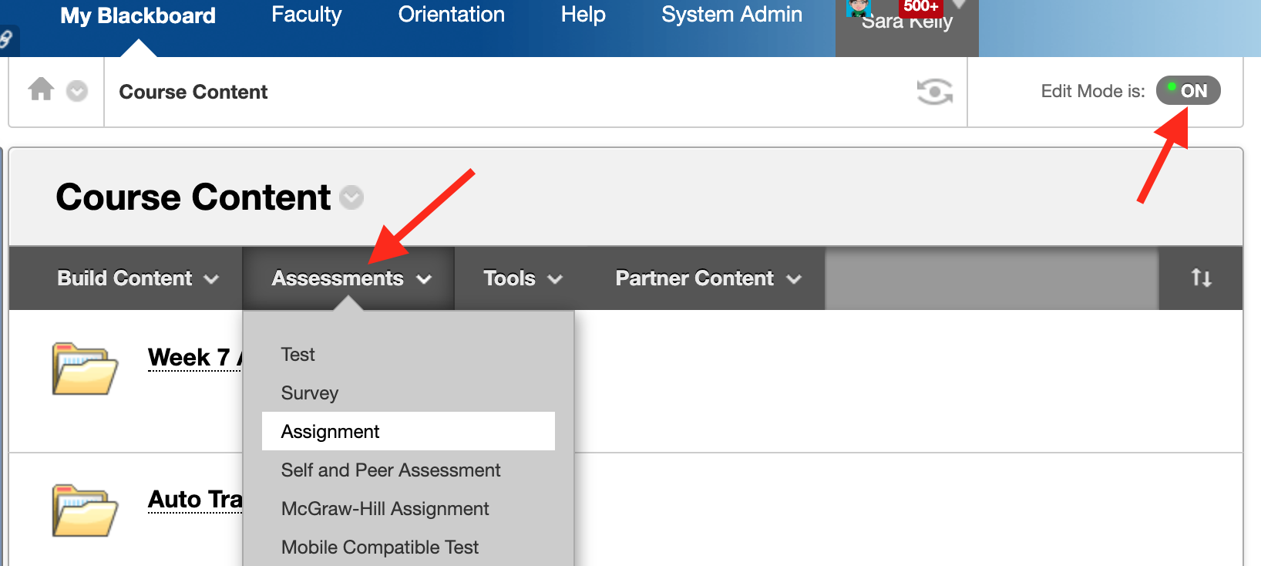

How do I change how many points the assignment is worth?

- Make sure the Edit Mode button is ON.
- Navigate to the assignment in the "Course Content" area.
- Click the down arrow to the right of the assignment name.
- You can edit the points, description, and recipient information from this screen.
- When you are finished, click Submit.

How do I change the assignment due date?

- Make sure the Edit Mode button is ON.
- Navigate to the assignment in the "Course Content" area.
- Click the down arrow to the right of the assignment name and select "Edit".
- To extend the availability of an assignment, change the "Display Until" date to the new date. Make sure you have both a "Display After" and "Display Until" date and checkmarks on the left next to both dates.
- The availability dates will override the due dates field. If you have a due date that is after the display until date, the students will only see the assignment until the display until date.
- When you are finished, click Submit.

How do I give students another attempt to submit an assignment?

- Go to the Full Grade Center
- Mouse over the cell with the student’s current submission and click the double down arrow to view the submission.
- Select "View Grade Details" from the drop-down list.
- On the Grade Detail screen, you have the option to allow additional attempts. Click the button to allow additional attempt to give the student one more opportunity to submit the work.
- Click "OK".

How do I move an assignment to another folder?

- Make sure the Edit Mode button is ON.
- Navigate to the assignment in the "Course Content" area.
- Click the down arrow to the right of the assignment name.
- Click "Move".
- Click the "Browse" button. A window will pop-up.
- Click the plus sign (+) next to "Course Content." If it shows a minus sign (-), it is already expanded.
- Click the folder title of the location where you would like to move the assignment. The pop-up box will disappear.
- When you are finished, click Submit.

Common Student Submission Problems

- The most common mistake is that they do not click "Submit" when they are finished. It sounds simple, but it's very common.

- The second problem students have with submitting assignments is that they do not attach the file. They simply click "Submit".

- Another common problem is that students will open the assignment, and then navigate away from the page. This opens an attempt in the Grade Center, but it is shown as "Not Completed". If this happens, the simplest thing to do is clear the blank attempt in the Grade Center.

